**Collage : Vishwakarma Institute of Technology**

**Course Name : Operating System**

**Name : Vedika Vikas Sontakke**

**Roll no : 37**

**PRN NO 12220206**

**Assignment No – 2**

**Shell programming :**

1. Basic Arithmatic :

* Write a shell script program to perform basic arithmetic operations :

Input :

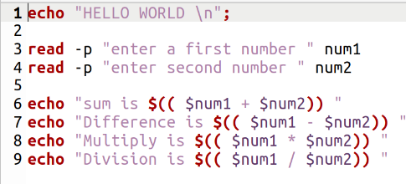

Output :

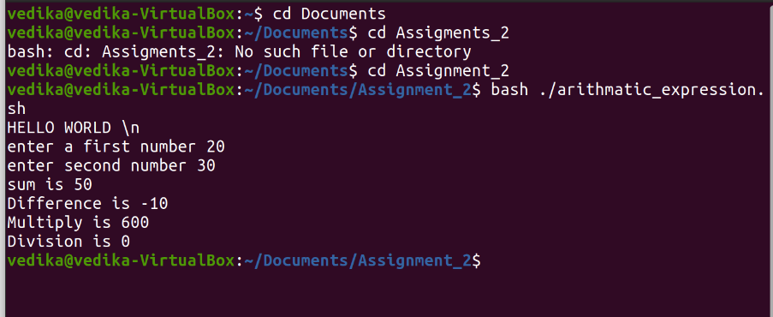

1. Control Structure :
2. If-else statment

* Write a program to find given number is even and odd

Input :

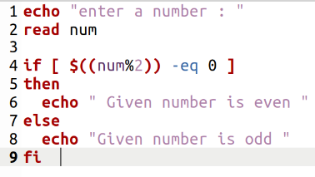

* Output :

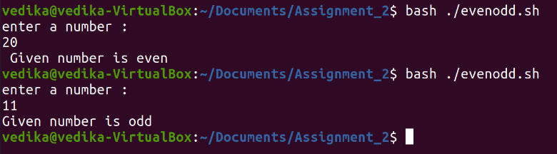

1. Switch case :

Input :

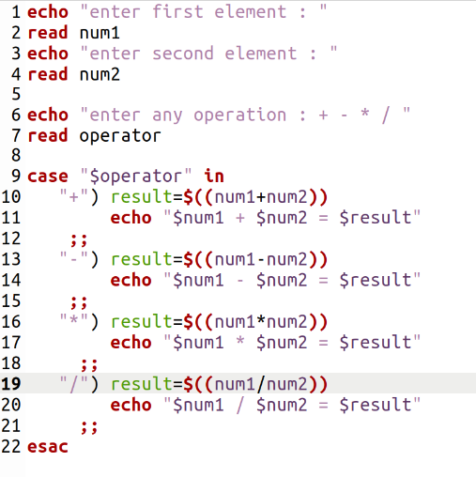

Output :

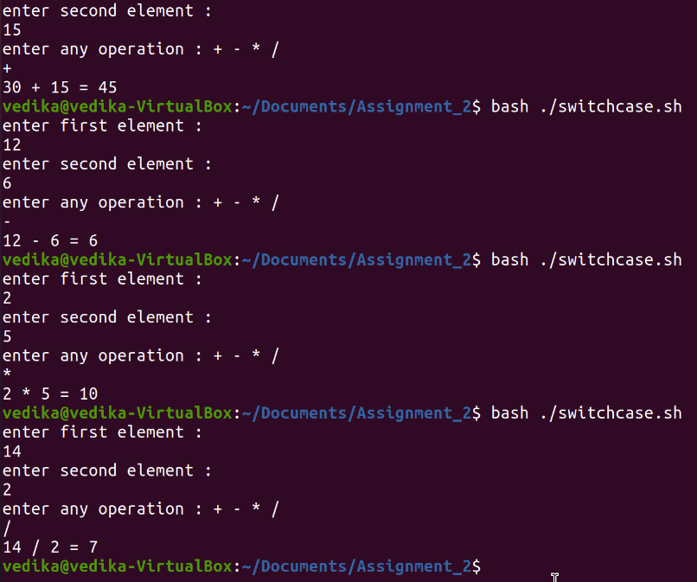

1. Loops
2. For – loop

* Write a shell script program to display table of a given number

Input :

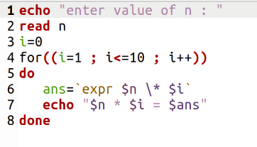

Output :

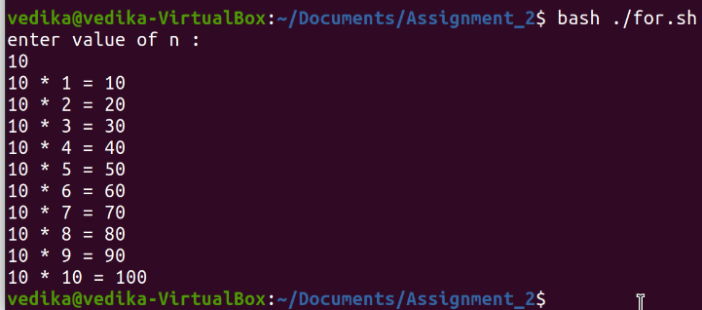

1. While – loop

* Write a program which will print the addition of the numbers upto given number

Input :

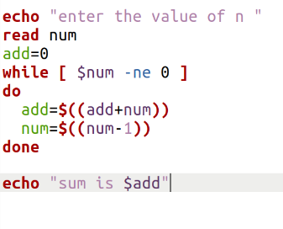

Output :

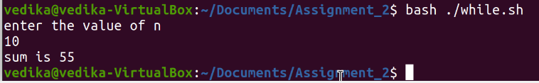

1. Command Line Argument

Input :

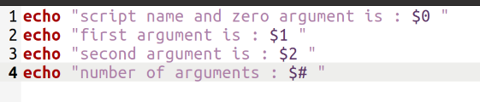

Output :

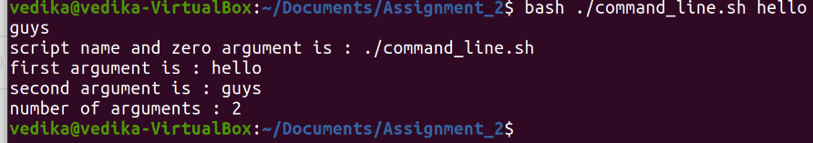

1. Functions

* Write a program which will print the addition of the numbers upto given number using functions

Input :

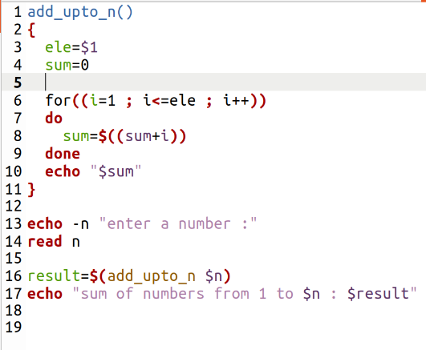

Output :

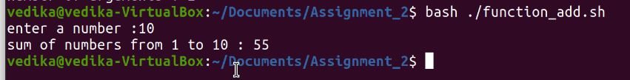

1. Array

* Write a program to create array having only even numbers

Input :

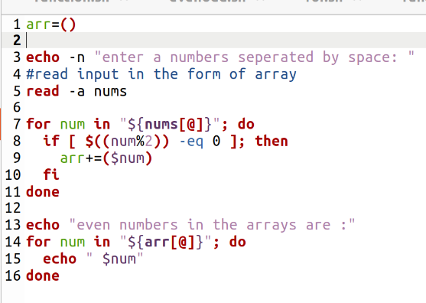

Output :

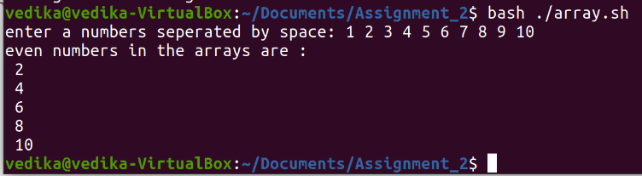

1. String

* Write a shell script program for the following operations :

1. Length
2. Concate
3. Lowercase
4. Uppercase
5. Slicing

Program :

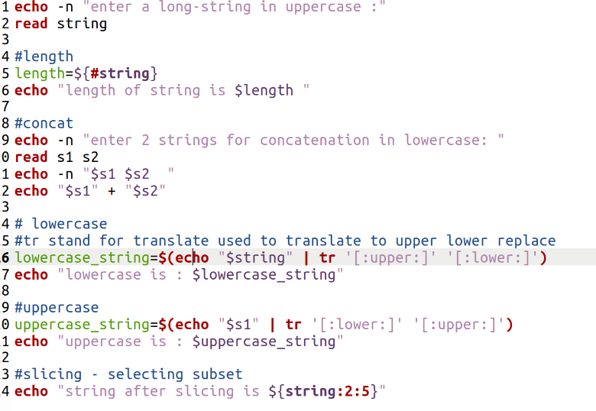

Output :

